Dance Party

Build a robot and program it to do a sequence of fancy dance moves. Dance should be less than 30 seconds long.

Base designs that work are:
- Artic Ride (part of the Great Adventures unit)
- Taxi Taxi (part of the Happy Traveler unit)
- Big Little Helper (part of the Quirky Creations unit)

Possible dance moves:
- Rock back and forth an inch or two.
- Shudder: rock back and forth about half an inch for a second or two.
- Turn to the right, turn to the left, but don’t really move.
- Hokey-pokey: put you left foot in, put your left foot out, shake your left foot about….
- Spin about the center of the robot.
- Spin around a wheel of the robot.
- Waltz: spin in a loose circle (inner wheel should form a circle about 2 inches in diameter) while moving in a larger circle (say 1 foot diameter)
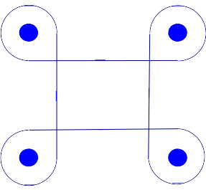
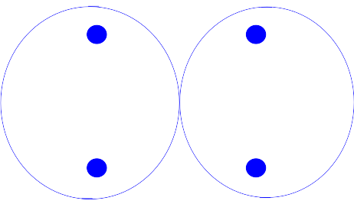
- Square dance is something like:

